**Project Initialization and Planning Phase**

| Date | 15 March 2024 |
| --- | --- |
| Team ID | 739799 |
| Project Name | WORLD HAPPINESS REPORT |
| Maximum Marks | 3 Marks |

**Define Problem Statements (Customer Problem Statement Template):**

While there is an abundance of data on happiness and well-being, the challenge lies in effectively analyzing this data to derive actionable insights. The current analysis methods often overlook the nuanced interplay between different factors that contribute to happiness. Furthermore, there is a need to identify and address the gaps in data collection and reporting, which can lead to a more accurate and holistic understanding of global happiness trends.

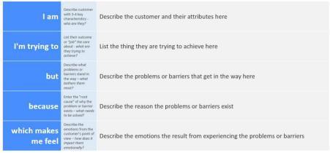

Reference: https://miro.com/templates/customer-problem-statement/

**Example:**

|  |  |  |  |  |  |
| --- | --- | --- | --- | --- | --- |
| **Problem**  **Statement (PS)** | **I am**  **(Customer)** | **I’m trying to** | **But** | **Because** | **Which makes me feel** |
| PS-1 | a policy-maker, | understand what influences global happiness | the factors are complex and libarate | current methods overlook interactions and have data gaps, | our understanding is incomplete, limiting effective policy-making. |